a) Do a search by selecting “Protein families (“COGs”) ... by protein sequence”,
Which orthologous group (COG number) does this protein belong to?
COG0109

b) Do a neighborhood analysis. What do you find? Which type of genes are
found in the neighborhood? Besides the neighborhood information what other
information can be found in the "Predicted functional partners" table?
The following proteins are the neighborhood, Protoheme ferro-lyase (ferrochelatase), Heme A synthase, Heme/copper-type cytochrome/quinol oxidase, subunit 4, Cytochrome c1, Cytochrome c oxidase assembly protein Cox11, Cytochrome oxidase assembly protein ShyY1, Cytochrome b subunit of the bc complex, NADH:ubiquinone oxidoreductase 20 kD subunit (chhain B) or related Fe-S oxidoreductase.
c) Go to the Fusion view page. This view shows the individual gene fusion
events per species. Protein evolution is sometimes accomplished by gene-
duplication and gene-fusion events. Do you find any evidence for a fusion
protein that has a domain related to P24009?
Fusion score 0.662 between COG0109 and COG1612
d) To what other domain (protein) is it fused?
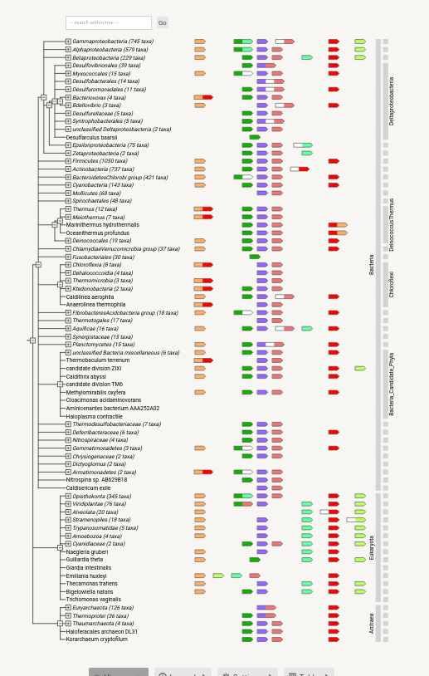

e) Find the corresponding protein in the organism that has the P24009 protein.
Acaricomes
f) Produce an in silico gene fusion by fusion the two protein sequences (use a
text editor to create the fused sequence). Then do a pair wise sequence
alignment of the natural fusion protein to the one you created. What is the
level of similarity? What does the presence of fused variants of this group of
proteins, tell us?
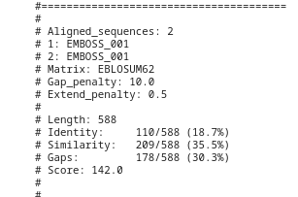

Which enzyme is catalyzing the last step in the biosynthesis of tryptophan? Is this enzyme present in Mycoplasma genitalium?tryptophan synthase, yes.

This bacterium was the second to be completely sequenced. This bacterium belongs
to a group of bacteria with very small genomes and no cell walls called
mycoplasmas. The EC number for, one of these enzymes in the citric acid cycle,
succinate dehydrogenase, is 1.3.99.1 (Changed to 1.3.5.1). Use this number to
search for the presence or absence of the Citric acid cycle in Mycoplasma genitalium
and Escherichia coli.
presence for Mycoplasma genitalium, and e.coil

